**Problem 2**

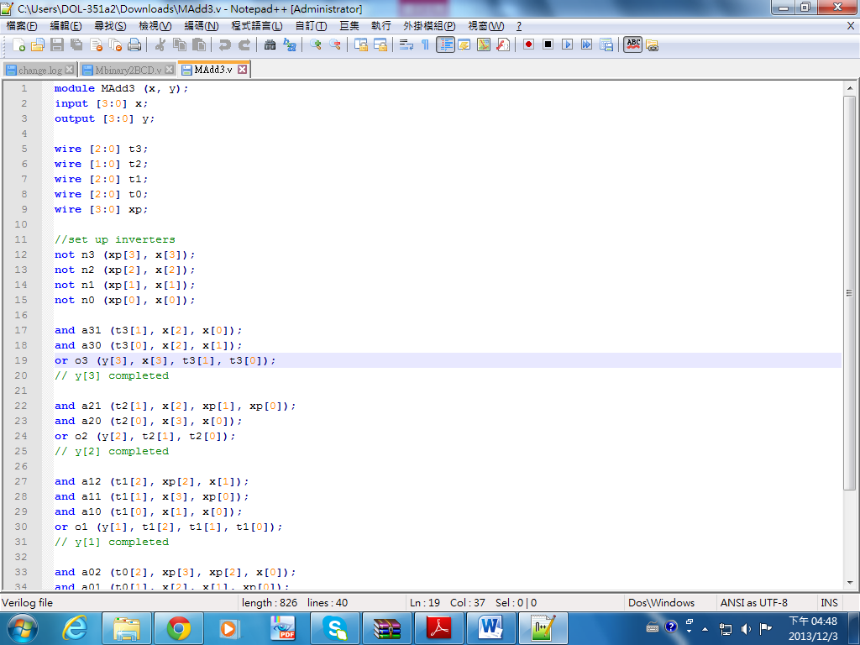module MAdd3 (x, y);

電機一 高紹芳 B02901035

**Verilog Assignment**

input [3:0] x;

output [3:0] y;

wire [2:0] t3;

wire [1:0] t2;

wire [2:0] t1;

wire [2:0] t0;

wire [3:0] xp;

//set up inverters

not n3 (xp[3], x[3]);

not n2 (xp[2], x[2]);

not n1 (xp[1], x[1]);

not n0 (xp[0], x[0]);

and a31 (t3[1], x[2], x[0]);

and a30 (t3[0], x[2], x[1]);

or o3 (y[3], x[3], t3[1], t3[0]);

// y[3] completed

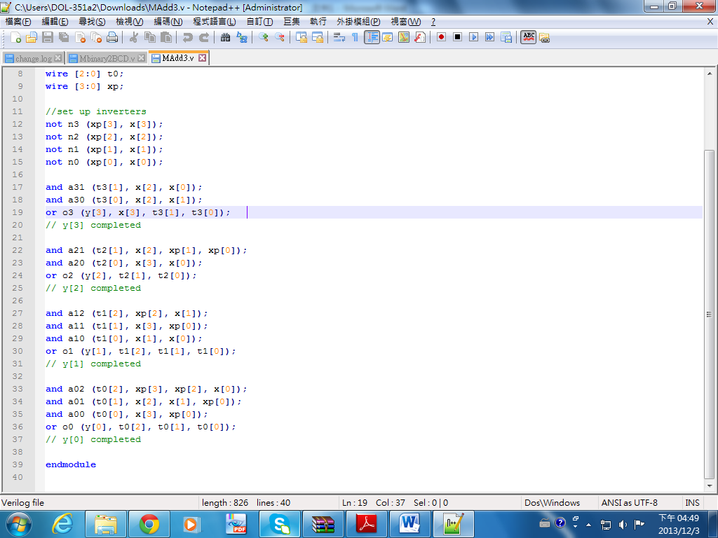

and a21 (t2[1], x[2], xp[1], xp[0]);

and a20 (t2[0], x[3], x[0]);

or o2 (y[2], t2[1], t2[0]);

// y[2] completed

and a12 (t1[2], xp[2], x[1]);

and a11 (t1[1], x[3], xp[0]);

and a10 (t1[0], x[1], x[0]);

or o1 (y[1], t1[2], t1[1], t1[0]);

// y[1] completed

and a02 (t0[2], xp[3], xp[2], x[0]);

and a01 (t0[1], x[2], x[1], xp[0]);

and a00 (t0[0], x[3], xp[0]);

or o0 (y[0], t0[2], t0[1], t0[0]);

// y[0] completed

endmodule

**Problem 3**

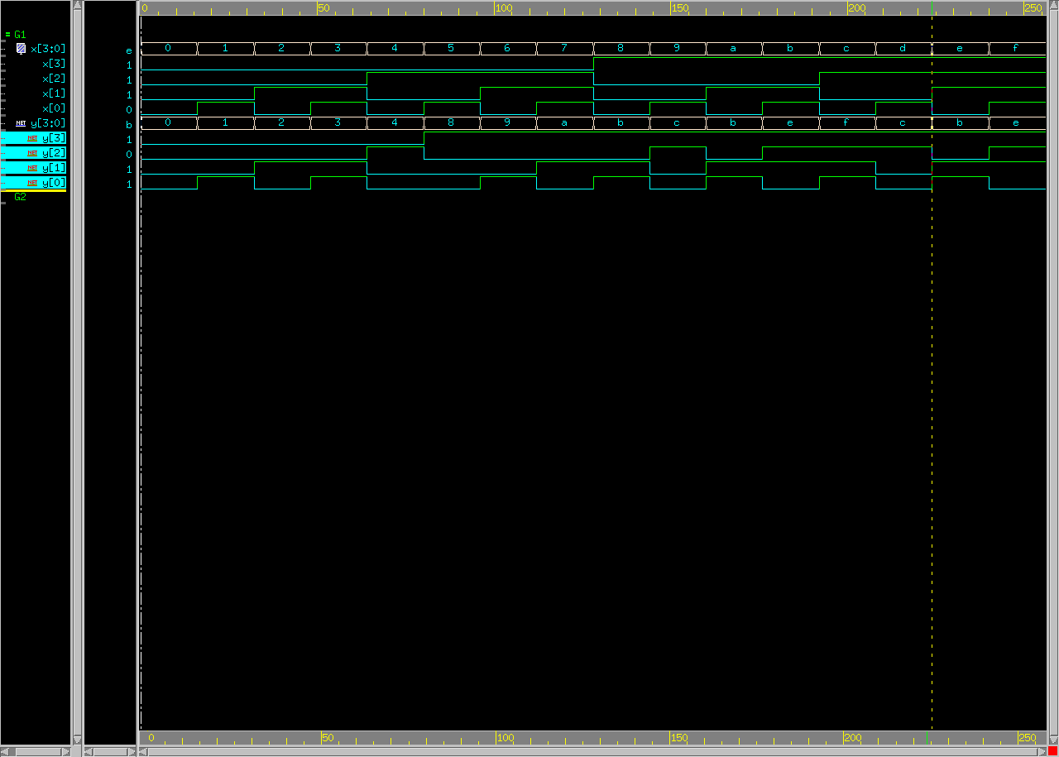

**Problem 4**

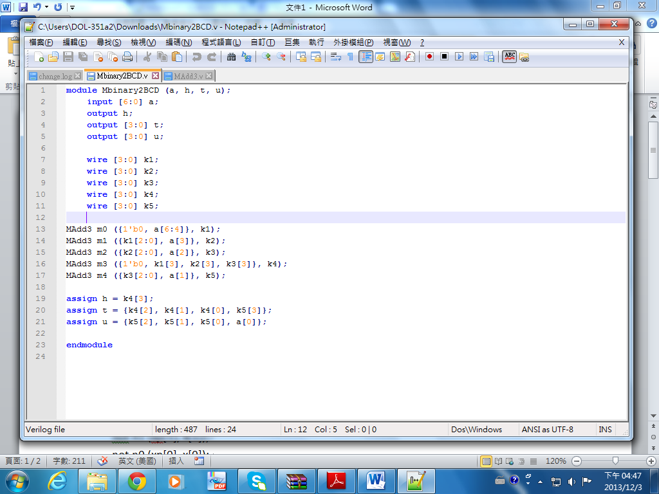module Mbinary2BCD (a, h, t, u);

input [6:0] a;

output h;

output [3:0] t;

output [3:0] u;

wire [3:0] k1;

wire [3:0] k2;

wire [3:0] k3;

wire [3:0] k4;

wire [3:0] k5;

MAdd3 m0 ({1'b0, a[6:4]}, k1);

MAdd3 m1 ({k1[2:0], a[3]}, k2);

MAdd3 m2 ({k2[2:0], a[2]}, k3);

MAdd3 m3 ({1'b0, k1[3], k2[3], k3[3]}, k4);

MAdd3 m4 ({k3[2:0], a[1]}, k5);

assign h = k4[3];

assign t = {k4[2], k4[1], k4[0], k5[3]};

assign u = {k5[2], k5[1], k5[0], a[0]};

endmodule

**Problem 5**

